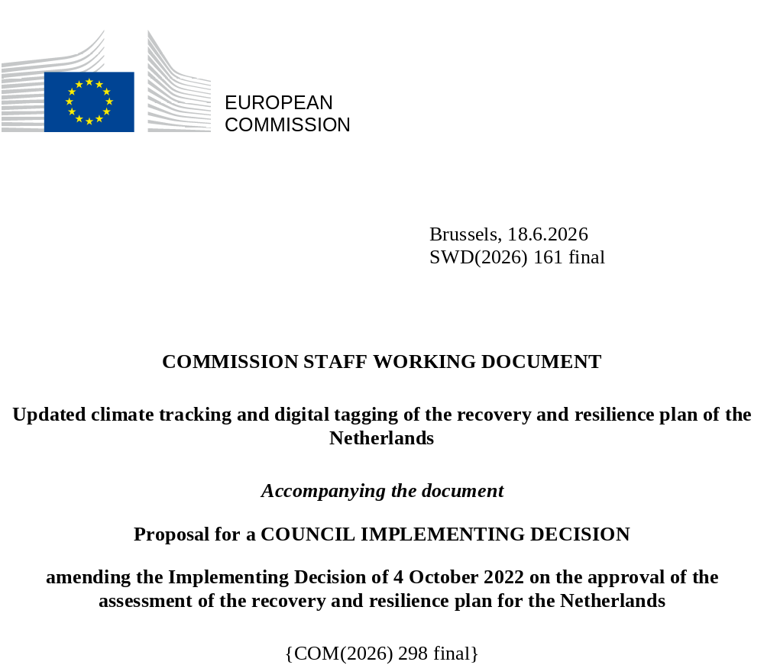

Updated climate tracking and digital tagging of the recovery and resilience plan of the Netherlands
The table below presents the detailed application of the climate tracking and digital tagging methodologies set out respectively in Annexes VI and VII to Regulation (EU) 2021/241 in the modified Dutch recovery and resilience plan.
Int. Field = intervention field.
Coeff. = Coefficient for the calculation of support to climate change objectives and to digital transition, on the basis of Annex VI and Annex VII of the RRF Regulation.
New or revised measures are marked in yellow to distinguish them from the unchanged measures in the RRP.
(Sub)-Measure ID | (Sub-)Measure Name | Cost (EUR mln) | Climate |  | Digital*
(Sub)-Measure ID | (Sub-)Measure Name | Cost (EUR mln) | Int. Field | Coeff. % | Int. Field | Coeff. %
P1.1I1.A | Offshore wind – ensuring shipping safety | 0 | 074 | 100%
P1.1I1.B | Offshore wind – electric  (re-)charging points at sea and in the quay | 0 | 077 | 100%
P1.1I1.C | Offshore wind – strengthening and protecting the North Sea ecosystem | 84 | 050 | 40%
P1.1I1.D | Offshore wind – proper integration of the power connection to land | 243 | 050 | 40%
P1.1I2.A | Green power of hydrogen – demonstration facilities | 30 | 032 | 100%
P1.1I2.B | Green power of hydrogen – research programme | 34 | 022 | 100%
P1.1I2.C | Green power of hydrogen – human capital agenda | 5 | 01 | 100%
P1.1I3 | Inland waterway energy transition, project ZES | 16 | 074 | 100%
P1.1I4.A | Aviation in transition – development and modification, in-flight testing and demonstration of components and systems in flight technology demonstrators based on hydrogen combustion | 10 | 022 | 100%
P1.1I4.B | Aviation in transition – floating vision | 19 | 027 | 100%
P1.1I5 | Subsidy scheme for electric personal vehicles (SEPP) | 270 | n.a.** | 100%
P1.1I6 | AanZET | 57 | n.a.** | 100%
P1.2I1 | Nature programme | 444 | 049 | 40%
P1.2I2 | Aid scheme for the rehabilitation of pig farms | 275 | 049 | 40%
P2.1I1 | Quantum Delta NL | 264 |  |  | 021quater | 100%
P2.1I2.A | AiNed and applied AI learning communities – development of highly specialised AI support services | 43 |  |  | 021ter | 100%
P2.1I2.B | AiNed and applied AI learning communities – development of digital skills | 16 |  |  | 108 | 100%
P2.1I3 | Digitalisation education impulse | 209 |  |  | 012 | 100%
P2.1I4 | Digital Infrastructure Logistics (DIL) | 36 | 084bis | 40% | 084bis | 100%
P2.2I1 | European Rail Traffic Management System (ERTMS) | 152 | 071 | 40% | 071 | 100%
P2.2I2 | Safe, smart and sustainable mobility | 47 | 076bis | 40% | 076bis | 100%
P2.2I3 | Intelligent Roadside Stations (IWKS) | 77 | 063bis | 40% | 063bis | 100%
P2.3I1 | Groundbreaking IT (GrIT) | 94 |  |  | 011 | 100%
P2.3I2 | Digitalisation of the criminal justice chain | 75 |  |  | 011quater | 100%
P3.1I1.A | Unlocking new construction projects – removal of bottlenecks | 28 | 048 | 40%
P3.1I1.B | Unlocking new construction projects – reducing nitrogen deposition | 1 | 049 | 40%
P3.1I1.C | Unlocking new construction projects – climate change adaptation | 49 | 037 | 100%
P3.2I1 | Subsidy scheme for sustainability of public sector real estate | 201 | 026 | 40%
P3.2I2.A | Investment subsidy for sustainable energy and energy savings for households (ISDE) | 504 | 025bis | 100%
P3.2I2.B | Investment subsidy for sustainable energy and energy savings for homeowners’ associations (SVVE) | 40 | 025 | 40%
P4.2I1 | National Education Lab AI | 26 |  |  | 012 | 100%
P4.2I5 | Laptops and tablets for online and hybrid education to combat and mitigate learning losses | 24 |  |  | 012 | 100%
P5.1I3 | SET COVID-19 | 50 |  |  | 013 | 100%
P5.1I4 | Health Research Infrastructure (HRI) | 22 |  |  | 013 | 100%
P8.I1 | Scaled-up measure: Investment subsidy for sustainable energy and energy savings (ISDE) | 1 417 | 025bis | 100%
While the estimated cost of the Netherlands’ recovery and resilience plan exceeds the total allocation of non-repayable financial support to the Netherlands, the Netherlands will ensure that all spending related to the measures mentioned in this table as contributing to climate objectives are fully financed by the funds from the Recovery and Resilience Facility.
* Reforms and investments in the REPowerEU chapter are not taken into account when calculating the plan’s contribution to the digital target requirement set by Regulation (EU) 2021/241.
** The ‘Methodology for climate tracking’ annexed to the Recovery and Resilience Facility Regulation does not set out intervention fields that would allow for climate or environmental tracking of electric vehicles, except for vehicles for urban transport falling under intervention field 074. According to Article 18(4)(e) of the Regulation, the methodology should however ‘be used accordingly for measures that cannot be directly assigned to an intervention field listed in Annex VI’. In this context, the Commission has applied a 100% climate contribution coefficient for zero-emission vehicles of all categories (this includes battery electric and fuel cell/hydrogen-powered vehicles) and low-emission heavy duty vehicles (trucks).

